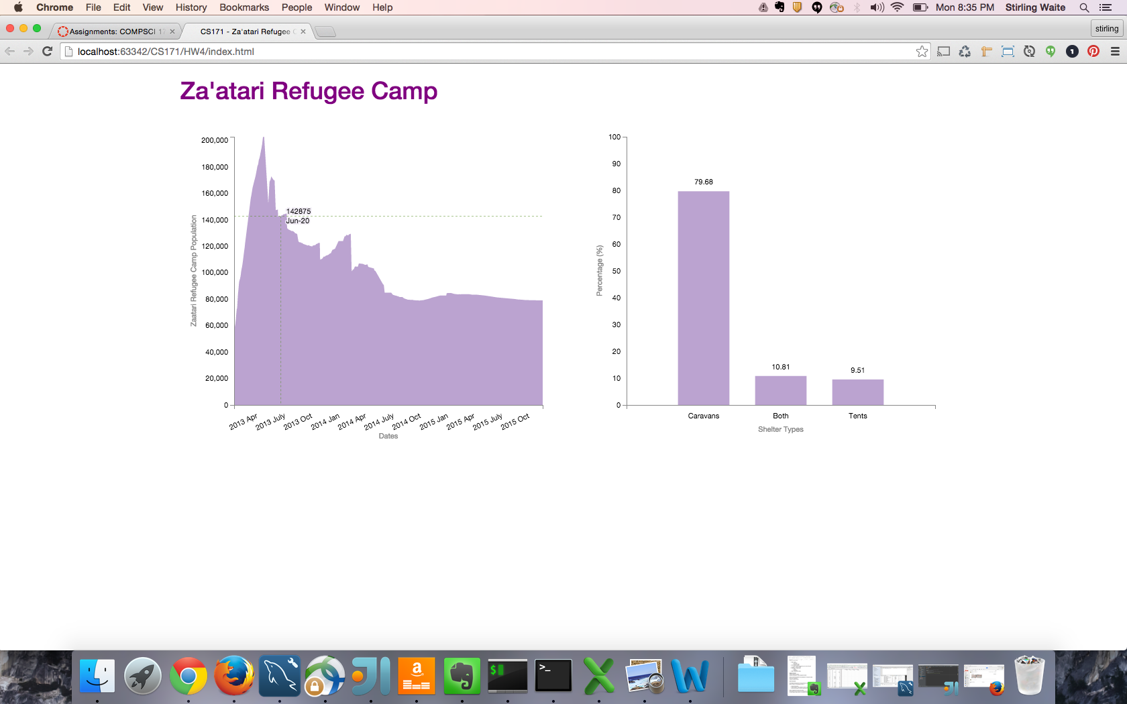

**2. Create an interaction storyboard**

**Design an interaction storyboard (branching storyboard) that uses at least three interaction**

**strategies for data and view specification or/and view manipulation. Imagine yourself in a**

**situation where you have to present your interaction concepts to a client.**

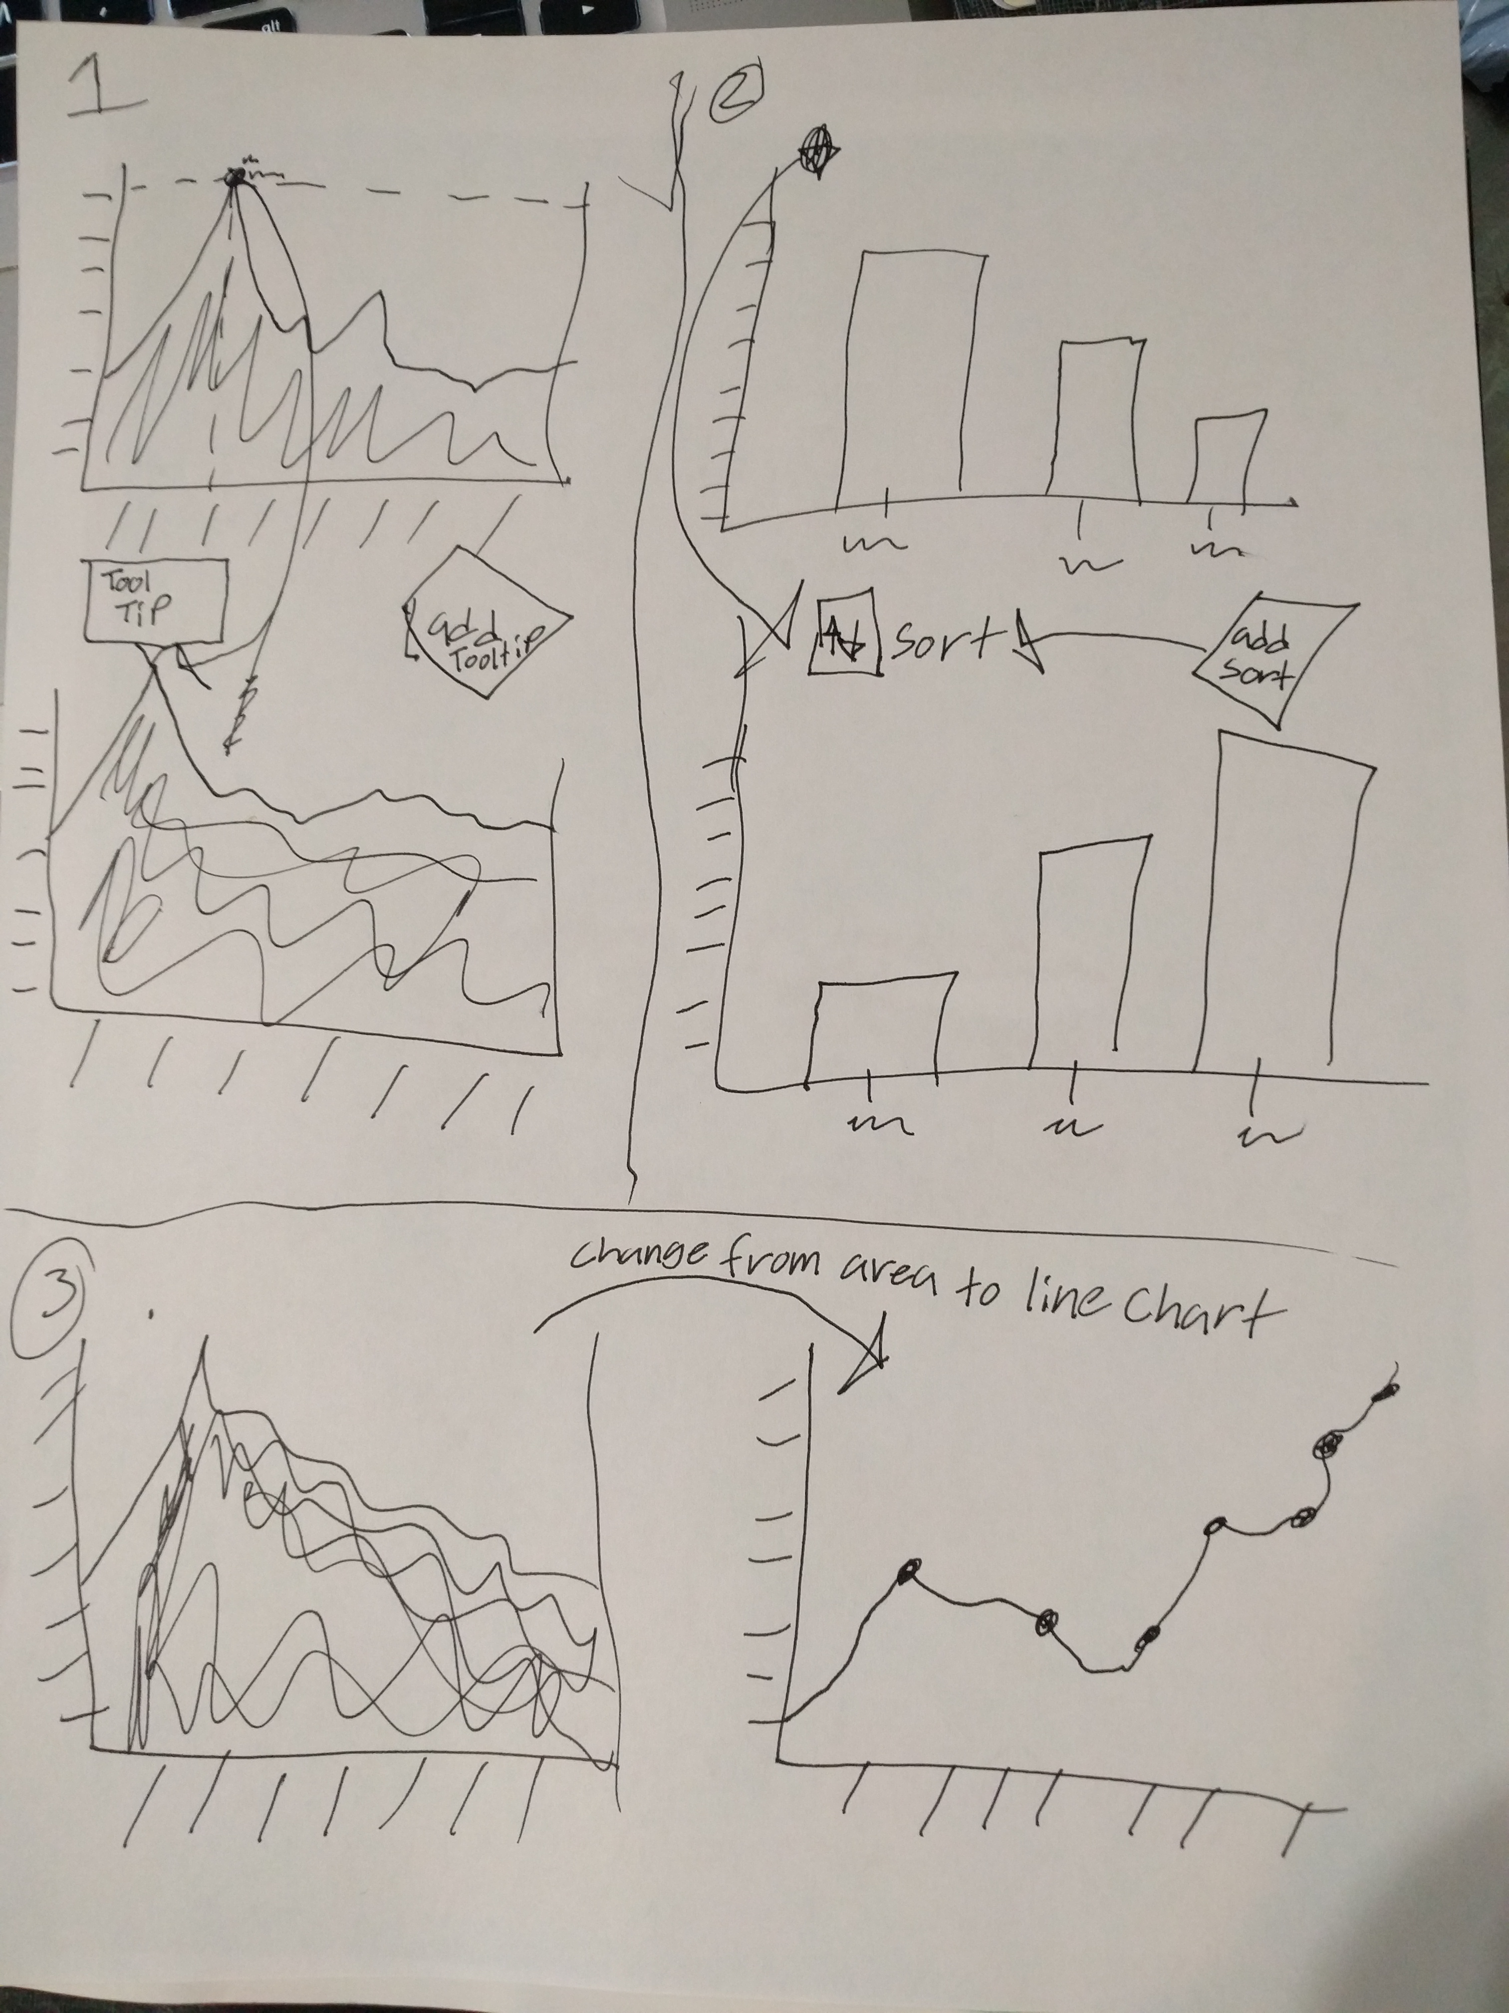

**3. Answer the following questions/tasks for EACH interaction:**

**Which questions can you answer by using your interactions?**

**Use the Heer & Schneiderman taxonomy to classify each interaction.**

* 1. **Question:** Can we add a tooltip when the user hovers on area chart?
  2. **Heer & Schneiderman:** View Manipulation
  3. **Question:** Can we add a sort button to change the x axis?
  4. **Heer & Schneiderman:** Data and View Specification
  5. **Question:** Can we change the area chart from an area chart to a line chart with multiple nodes?
  6. **Heer & Schneiderman:** View Manipulation